DONE:

1.Completed the verification of KPE computing component.

2.verified the 16bit-precision LPE_SPRMPS_ALL mode LPE computing component.

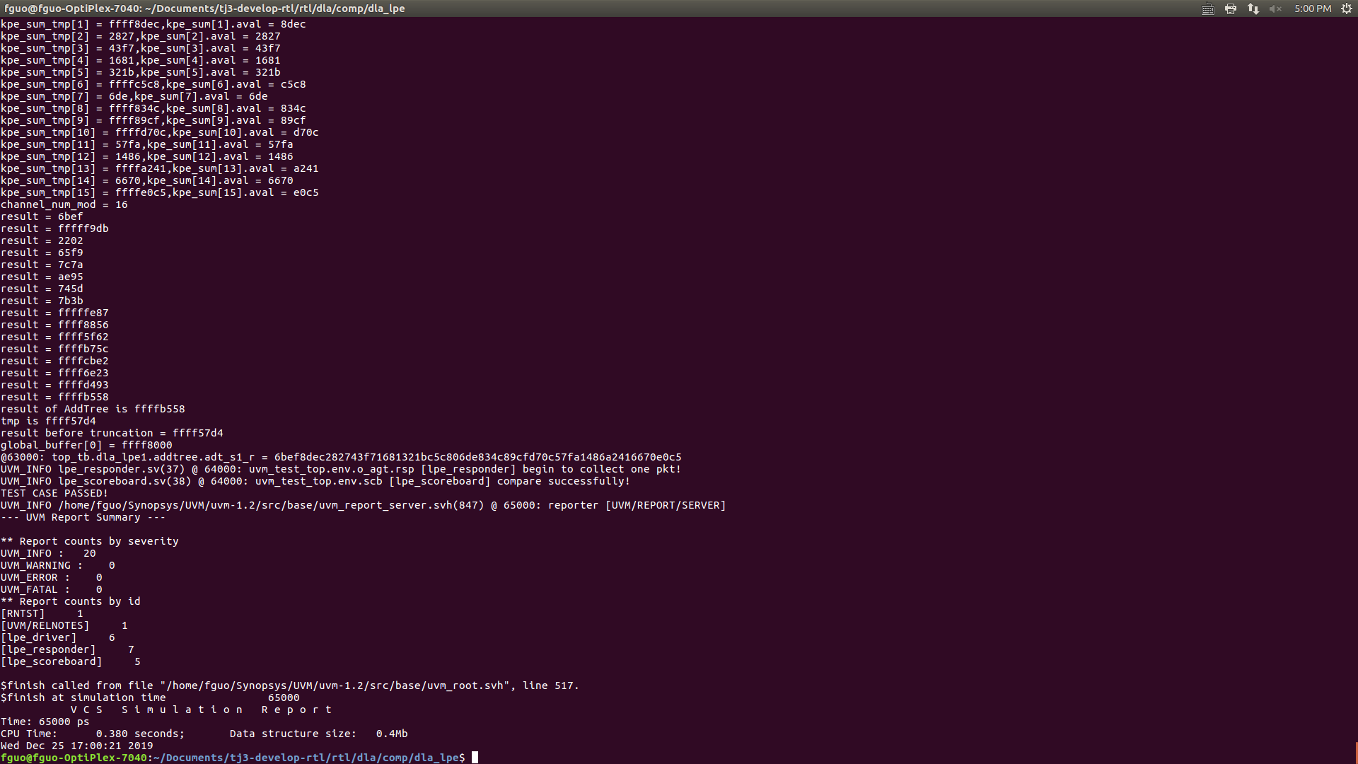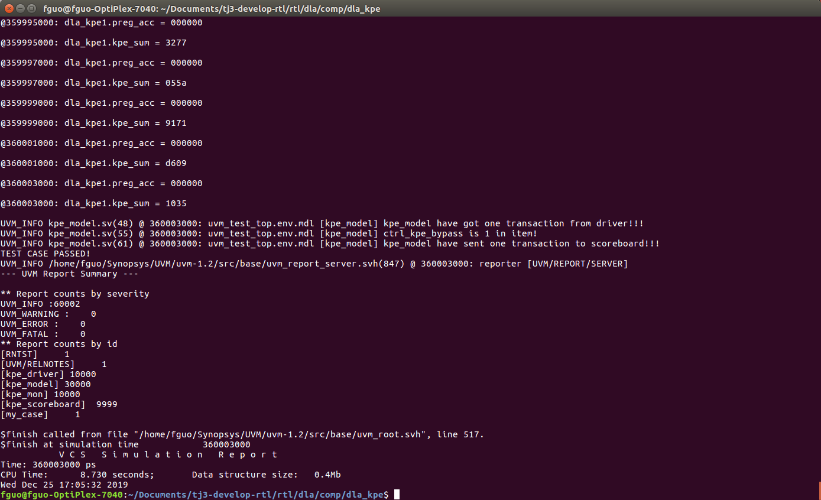

TO DO:

1. Complete the LPE computing component.

2. Try to simulate the KPE computing and control component together.